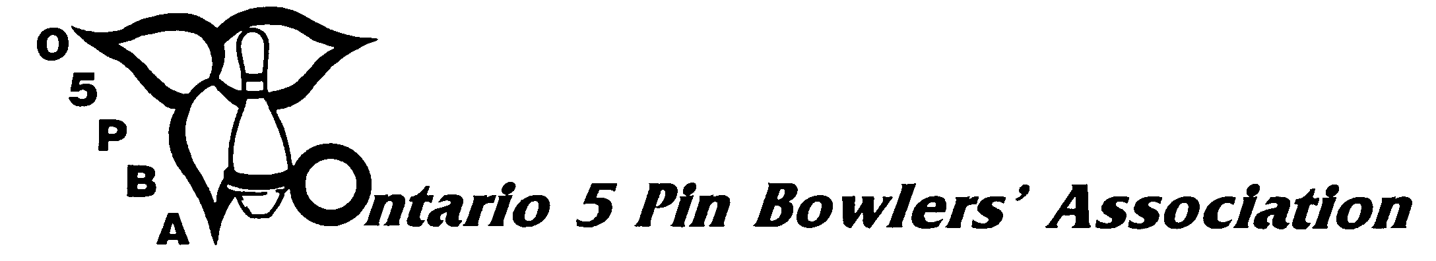
3 Concorde Gate, Suite 302, Toronto, Ontario, M3C 3N7
Telephone: (416) 426-7167 Fax: (416) 426-7364 Website: www.o5pba.ca

AFFILIATED LEAGUE BANK BALANCE VERIFICATION

To be completed each month by the President of the Sanctioned League, following personal verification at the bank of the monthly balance as reported by the League Treasurer in each bank account operated by the sanctioned league.

This form, when completed and signed by the League President, must be sent to the Local Zone or D.C. Association for retention in their files. Please do not send to the Ontario 5 Pin Bowlers’ Association.

League President’s Signature:
League President’s Name:
Address:
City/Town:
Postal Code:
Telephone: | Home: Business:
League Name:
Bowling Centre:

Name of Bank:
Account Number/Account Name:
Branch Street Address:
Month Bank Balance Verified:

Is amount same as Treasurer’s last report? YES ( ) NO ( )

If not, explain discrepancy:

